COVID-19 BANK FACILITIATED PROCUREMENT
Commander Health Supply
June 02, 2020

Commander Health Supply, LLC is a US-based healthcare supply company based in Bronxville, New York, and was formerly known as Dynamic Goose, LLC.

Offer Expiration Date:

Borrowers must send the completed Registration of Interest (ROI) form by June 10, 2020, confirming which products and quantities are needed.

Following receipt of the Registration of Interest, Commander Health Supply will confirm lead times and quote CIP pricing. In parallel, World Bank Procurement will draft the contract for the Borrower and send this to you for presentation to the Borrower (this will include any pricing changes).

Borrowers must sign final contracts by June 19, 2020. If the Borrower is late then Commander Health Supply will revise the lead time to a later date and may also increase prices.

Also, please ensure the borrower signs the BFP letter before signing the final contract.

PPE Products offered by Commander Health Supply:

- Mask, patient, disposable
- Mask, healthcare worker, disposable
- Mask, respirator, KN95/N95
- Goggles, protective
- Gloves, examination
- Gown, medical, disposable

Details about standards met for each product are described in Appendix One. Most of the contracted products meet World Health Organization (WHO) or comparable international standards. It is at the sole discretion of the borrower as to whether they would like to purchase products that meet comparable Chinese standards.

Commander Health Supply has offered commercial-grade KN95 respirator masks that meet Chinese Standard - GB2626, not medical KN95 respirator masks that meet Chinese Standard – GB19083 due to limited availability. The key difference between the two masks is synthetic blood penetration testing that is performed on the medical KN95 respirator mask, and not performed on a commercial KN95 respirator mask. According to the US Centers for Disease Control and Prevention (CDC), a surgical N95 (equivalent to medical KN95) in times of a shortage is recommended only for use by healthcare personnel working in a sterile field or who may be exposed to high velocity splashes, sprays, or splatters of blood or body fluids. A more detailed review of this difference is provided in Appendix 2.

Legal and other issues to highlight to Borrowers:

Pricing: Please see the ROI form attached. Each country will need to complete an ROI. Prices are in US dollars.

Inspection: Inspection and testing will be performed prior to and during production along with a final random inspection of finished products by a Bank approved independent inspection agency. The inspection contract will be let by Commander Health Supply to the approved inspection agency with costs passed through to the Borrower to pay.

Delivery: Quoted prices are Free on Board (FOB), where the borrower is responsible for the cost of shipping and insurance from the country of origin to the product’s final destination in their country.
Upon receipt of your ROI, Commander Health Supply will propose CIP pricing, where it would organize the delivery of goods to the agreed destination.

Delivery times: 20-35 days from date of first advance payment to delivery to warehouse at country of manufacturer’s airport

Advanced payment: 40% on order
60% on final acceptance of product

Borrower and Commander Health Supply Next Steps:

- Borrower completes the ROI, including acknowledgement of acceptance of proposed standards for products.

- E-mail the completed ROI form by June 10, 2020 to Mukesh, copying kriek@ecri.org and agolding@worldbankgroup.org
- OPCS will forward the ROI to Commander Health Supply and begin drafting the contract for the Borrower.
- OPCS will send the draft contract to the TTL and the Country Procurement Specialist so they can add final local details e.g. Legal name of Purchaser, name of signatory etc. Note, contracts are not open to renegotiation by Borrowers.
- TTL (supported by Country Procurement Specialist) presents the final contract to the Borrower for their decision and if agreed signature. (Note: Contracts are to be signed by June 19, 2020 to maintain lead times and pricing offered. If Borrowers are late then these will likely increase.)
- If the Borrower signs the contract, the Borrower sends the signed contract to Commander Health Supply directly (details will be provided in the contract) copying the TTL and kriek@ecri.org.
- Commander Health Supply will return a signed copy of the contract to the Borrower copying the TTL and kriek@ecri.org.
- If the Borrower decides not to proceed or sign the contract (which is fine), please e-mail (with the reason) to Mukesh copying agolding@worldbankgroup.org and kriek@ecri.org.

Commander Health Supply Offered Products Summary

 | World Health Organization |  |  | Commander Health Supply Proposed Product
 | Product | Description | Standards | Catalog # and photo | International Standards Met by Proposed Product | Comments on  Proposed Products
1 | Mask, patient, disposable | Surgical mask, good breathability, internal and external faces should be clearly identified Type I | • EN 14683 Type I or higher  • ASTM F2100 minimum level 1  or equivalent | 3 Ply Disposable Medical Mask  SUM002  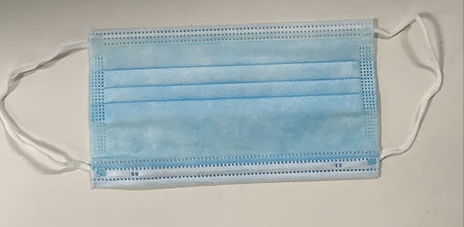 | EN 14683 Type I | Meets WHO standard
2 | Mask, healthcare worker, disposable | Surgical mask, good breathability, internal and external faces should be clearly identified Type II or higher | • EN 14683 Type II, IR, IIR  • ASTM F2100 minimum level 1  • EU MDD Directive 93/42/EEC Category III  or equivalent | 3 Ply Disposable Surgical Mask  SUM003 | EN14683 Type II R | Meets WHO standard
3 | Mask, respirator, KN95 | N95 or FFP2 respirator, or higher. Good breathability with design that does not collapse against the mouth (e.g. duckbill, cup-shaped) | • Surgical/Medical rated (commercial rated is not preferred, but is acceptable if used with a face shield per recent US CDC recommendations)  • Non-valved (valved is not preferred)  • Minimum "N95" respirator according to FDA Class II, under 21 CFR 878.4040, and CDC NIOSH, or  • Minimum "FFP2" according to EN 149, or  • EU PPE Regulation 2016/425 Category III,  or equivalent | KN95 5-layer  5W002  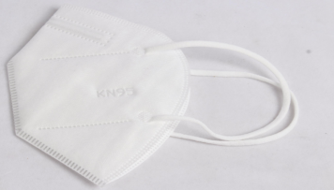  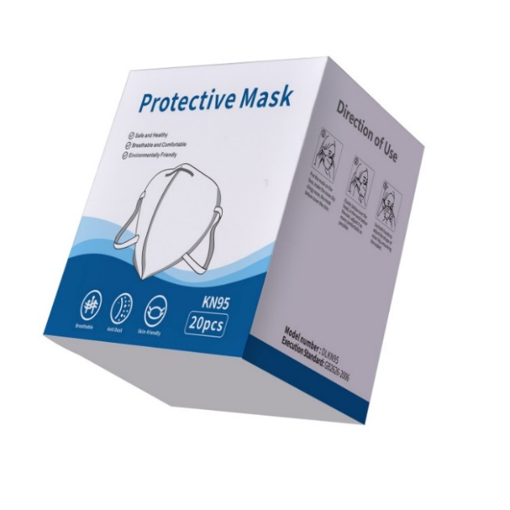 | EN149:2001+A1:2009 – FFP2  GB2626-2006 | GGB2626 for commercial KN95 is acceptable for non-surgical/non-splatter environment  GB2626 for commercial KN95 is acceptable if also used with a face shield in a splatter environment per recent US Center for Disease Control recommendations
4 | Mask, respirator, KN95 | N95 or FFP2 respirator, or higher. Good breathability with design that does not collapse against the mouth (e.g. duckbill, cup-shaped) | • Surgical/Medical rated (commercial rated is not preferred, but is acceptable if used with a face shield per recent US CDC recommendations)  • Non-valved (valved is not preferred)  • Minimum "N95" respirator according to FDA Class II, under 21 CFR 878.4040, and CDC NIOSH, or  • Minimum "FFP2" according to EN 149, or  • EU PPE Regulation 2016/425 Category III,  or equivalent | Fold Particular Respirator KN95/FFP2 NR  SUM004  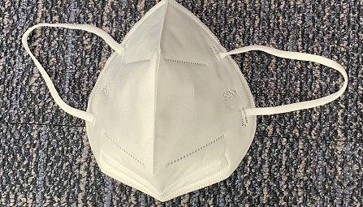 | EN149:2001+A1:2009  GB2626-2006 | GGB2626 for commercial KN95 is acceptable for non-surgical/non-splatter environment  GB2626 for commercial KN95 is acceptable if also used with a face shield in a splatter environment per recent US Center for Disease Control recommendations
5 | Mask, respirator, N95 | N95 or FFP2 respirator, or higher. Good breathability with design that does not collapse against the mouth (e.g. duckbill, cup-shaped) | • Surgical/Medical rated (commercial rated is not preferred, but is acceptable if used with a face shield per recent US CDC recommendations)  • Non-valved (valved is not preferred)  • Minimum "N95" respirator according to FDA Class II, under 21 CFR 878.4040, and CDC NIOSH, or  • Minimum "FFP2" according to EN 149, or  • EU PPE Regulation 2016/425 Category III,  or equivalent | Fold N95 Particular Respirator with NIOSH approved  SUM005  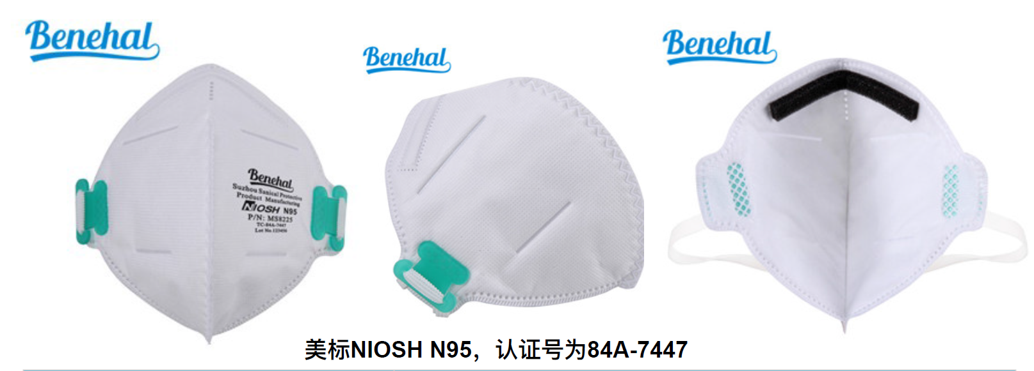 | NIOSH EN149:2001+A1:2009  GB2626-2006 | GGB2626 for commercial KN95 is acceptable for non-surgical/non-splatter environment  GB2626 for commercial KN95 is acceptable if also used with a face shield in a splatter environment per recent US Center for Disease Control recommendations
6 | Mask, respirator, N95 | N95 or FFP2 respirator, or higher. Good breathability with design that does not collapse against the mouth (e.g. duckbill, cup-shaped) | • Surgical/Medical rated (commercial rated is not preferred, but is acceptable if used with a face shield per recent US CDC recommendations)  • Non-valved (valved is not preferred)  • Minimum "N95" respirator according to FDA Class II, under 21 CFR 878.4040, and CDC NIOSH, or  • Minimum "FFP2" according to EN 149, or  • EU PPE Regulation 2016/425 Category III,  or equivalent | Mold N95 Particular Respirator with NIOSH approved  SUM006  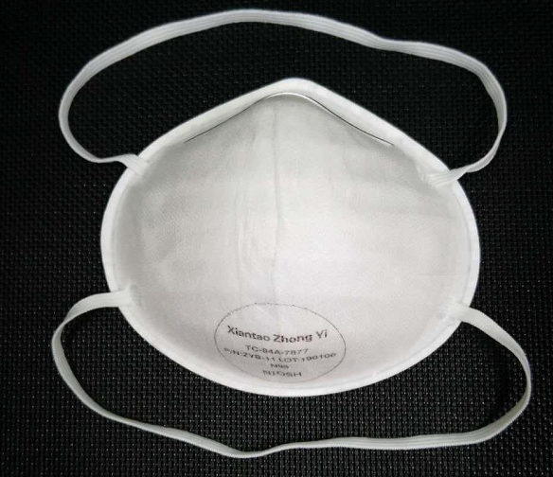 | NIOSH EN149:2001+A1:2009  GB2626-2006 | GGB2626 for commercial KN95 is acceptable for non-surgical/non-splatter environment  GB2626 for commercial KN95 is acceptable if also used with a face shield in a splatter environment per recent US Center for Disease Control recommendations
7 | Goggles, protective | Good seal with the skin of the face, flexible PVC frame to easily fit with all face contours with even pressure, enclose eyes and the surrounding areas, accommodate wearers with prescription glasses, clear plastic lens with fog and scratch resistant treatments, adjustable band to secure firmly so as not to become loose during clinical activity, indirect venting to avoid fogging. May be re-usable (provided appropriate arrangements for decontamination are in place) or disposable. | • EU PPE Regulation 2016/425  • EN 166  • ANSI/ISEA Z87.1  or equivalent | 5W003  Open venting  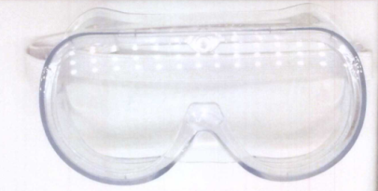 | EN 166:2001，GB/T14866-2006，GB/T32166.2-2016 | Meets WHO standards
8 | Gloves, examination, nitrile | Gloves, examination, nitrile, powder-free, non-sterile, single-use  Gloves should have long cuffs, reaching well above the wrist, ideally to mid-forearm. Sizes: small, medium, large. | • EU MDD Directive 93/42/EEC Category III  • EU PPE Regulation 2016/425 Category III  • EN 455  • EN 374  • ANSI/ISEA 105,  • ASTM D6319,  or equivalent | Nitrile Gloves – Examination/Medical  SUM010  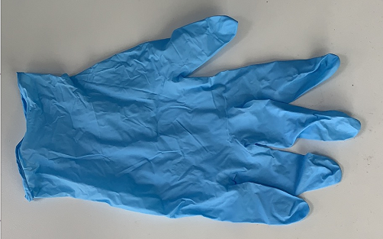 | EN455&EN374 ASTM D6319 ASTM F1671 510(K) | Meets WHO standards  D6319 is ASTM’s standard for nitrile gloves
9 | Gloves examination, vinyl | Gloves, examination, nitrile, powder-free, non-sterile, single-use  Gloves should have long cuffs, reaching well above the wrist, ideally to mid-forearm. Sizes: small, medium, large. | • EU MDD Directive 93/42/EEC Category III  • EU PPE Regulation 2016/425 Category III  • EN 455  • EN 374  • ANSI/ISEA 105,  • ASTM D6319,  or equivalent | Vinyl Gloves – Examination/Medical  SUM011  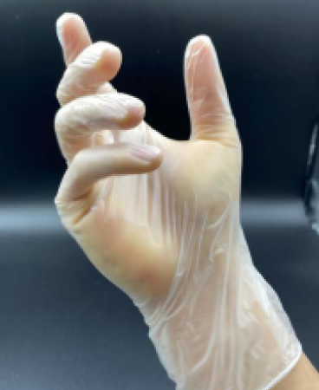 | GB 4806.7-2016 EN455&EN374 ASTM D5250 510(K) | Meets WHO standards  D5250 is ASTM’s standard for vinyl gloves
10 | Gown, medical, disposable | Single-use, length mid-calf. | • EU PPE Regulation 2016/425 and EU MDD Directive 93/42/EEC  • FDA Class I or II medical device, or equivalent  • EN 13795 any performance level, or  • AAMI PB70 all levels acceptable,  or equivalent | Isolation Gown (Class 1 Level 2 & Level 3)  SUM007  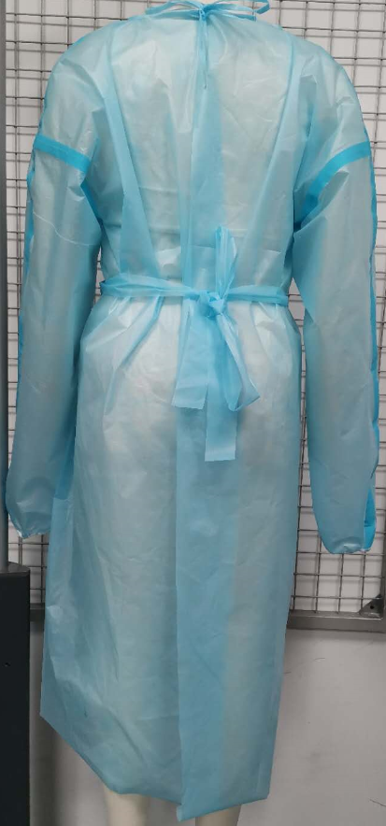  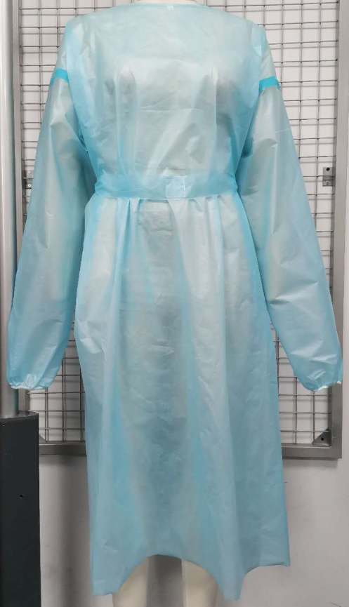 | ANSI/AAMI PB70-2012 | Meets WHO standards
11 | Gown, medical, disposable | Single-use, length mid-calf. | • EU PPE Regulation 2016/425 and EU MDD Directive 93/42/EEC  • FDA Class I or II medical device, or equivalent  • EN 13795 any performance level, or  • AAMI PB70 all levels acceptable,  or equivalent | Surgical Gown (Class 2)  FDA Class II 510(k)  SUM008  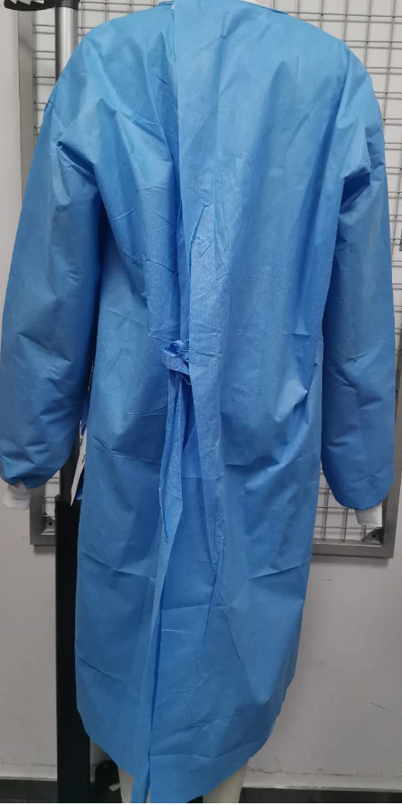  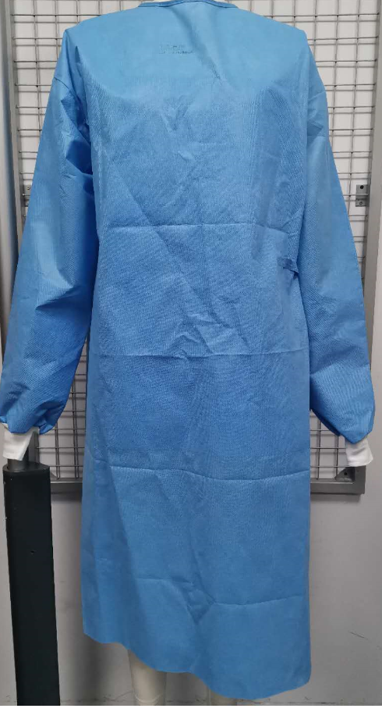 | ANSI/AAMI PB70-2012 (ASTM F1671-2013) EN 13795 | Meets WHO standards
12 | Gown, medical, disposable | Single-use, length mid-calf. | • EU PPE Regulation 2016/425 and EU MDD Directive 93/42/EEC  • FDA Class I or II medical device, or equivalent  • EN 13795 any performance level, or  • AAMI PB70 all levels acceptable,  or equivalent | Surgical Gown (Class 2)  SUM009 | ANSI/AAMI PB70-2012 (ASTM F1671-2013) EN 13795 | Meets WHO standards

Description of Commercial and Medical KN95 Respirator Masks

Commander Health Supply, LLC proposed a commercial KN95 respirator masks (Chinese Standard - GB2626), not medical KN95 respirator masks (Chinese Standard – GB19083) due to limited availability. The key difference between the two masks is the synthetic blood penetration testing that is performed on the medical KN95 respirator mask, and not performed on a commercial KN95 respirator mask. The Chinese standard GB19083 and equivalent international standards (e.g., NIOSH surgical N95 respirator mask) tests for blood penetration for medical/surgical KN95/N95 masks. The GB19083 standard also tests for surface wetting resistance and bioburden, which other international surgical N95 respirator mask standards do not require.

Regarding the use of commercial versus medical N95 (and equivalent KN95 masks), the US Centers for Disease Control and Prevention (CDC), in their webpage Frequently Asked Questions about Personal Protective Equipment, says, “a surgical N95 is recommended only for use by healthcare personnel (HCP) who need protection from both airborne and fluid hazards (e.g., splashes, sprays). These respirators are not used or needed outside of healthcare settings. In times of shortage, only HCP who are working in a sterile field or who may be exposed to high velocity splashes, sprays, or splatters of blood or body fluids should wear these respirators, such as in operative or procedural settings. Most HCP caring for confirmed or suspected COVID-19 patients should not need to use surgical N95 respirators and can use standard N95 respirators. If a surgical N95 is not available for use in operative or procedural settings, then an unvalved N95 respirator may be used with a faceshield to help block high velocity streams of blood and body fluids.” The proposed commercial KN95 masks from Commander Health Supply, LLC do not have valves.

Frequently Asked Questions about Personal Protective Equipment, U.S. Centers for Disease Control and Prevention, updated February 29, 2020.

